17.113: a) See Figure 17.11. As the temperature approaches 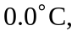 the coldest water rises to the top and begins to freeze while the slightly warmer water, which is more dense, will be beneath the surface. b) (As in part (c), a constant temperature difference is assumed.) Let the thickness of the sheet be 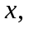 and the amount the ice thickens in time 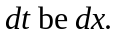 The mass of ice added per unit area is then 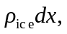 meaning a heat transfer of 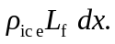 This must be the product of the heat flow per unit area times the time, 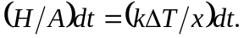 Equating these expressions,
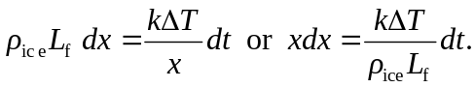
This is a separable differential equation; integrating both sides, setting 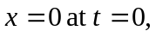 gives
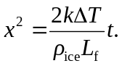
The square of the thickness is propotional to the time, so the thickness is propotional to the square root of the time. c) Solving for the time in the above expression,
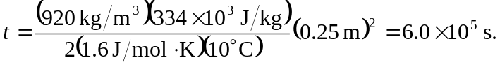
d) Using 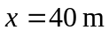 in the above calculation gives 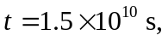 about 500 y, a very long cold spell.

